**LAB REPORT PART A**

**Contributing to an Open-Source Project:**

- Contributing to an open-source project means actively participating in its development and improvement by offering your time, skills, and expertise. Open-source projects are software projects where the source code is made freely available to the public, allowing anyone to view, use, modify, and distribute it. You can just navigate to their repository, open the files, analyze the code, change according to yourself and reuse it as per your requirement.

- A more technical definition of open-source projects is that they are released under a license in which the copyright owner allows the users to change, analyze and redistribute the code as they want. The license is generally available along with the **README** file in the repository.

- The software thus released is developed not by a particular organization but a community altogether. Since the users can also read the code, it increases the trust factor which in turn

increases the acceptability rates and hence the downloads.

The **steps to contribute to an Open Source** Project are:

1. Finding a Project: The first step is to find an open-source project that

interests you and aligns with your skills and knowledge. There are countless

projects available on platforms like GitHub, GitLab, and Bitbucket, covering

a wide range of topics and technologies.

2. Understanding the Project: Once you've chosen a project, take the time to

understand its goals, structure, and codebase.

3. Identifying Contributions: You can contribute to an open-source project in

various ways, such as fixing bugs, adding new features, improving

documentation, enhancing user interfaces, writing tests, optimizing code, or

helping with community support.

4. Forking the Project: To start contributing, you typically create a fork of

the original project. This creates a copy of the project under your account,

allowing you to freely

experiment with changes without affecting the main project.

5. Making Changes: Using your fork, you can make changes to the codebase

or documentation. Once you're satisfied with your changes, you can commit

them to your forked repository.

6. Creating Pull Requests (PRs): After committing your changes, you

propose them to be merged back into the original project through a pull

request (PR).

7. Merging and Recognition: If your contributions meet the project's

standards and align with its goals, the maintainers will merge your changes

into the main project.

**Collaborative Development:**

- Collaborative development is the driving force behind the success and growth of the software community. It enables individuals from diverse backgrounds and skill sets to come together, share their expertise, and collectively create high-quality, innovative, and reliable open-source software. Through collaborative efforts, developers can build upon each other's work, identify and fix bugs, introduce new features, and continuously improve existing projects. This culture of collaboration fosters a spirit of knowledge-sharing and mutual support, propelling the software community forward and making technology more accessible, robust, and beneficial for users worldwide.

- Rich diversity leads to the discovery of novel solutions and thorough code reviews, resulting in higher-quality software. As a result, the software community thrives, ushering in an era of continuous innovation and advancement that benefits society as a whole.

**The repositories are as follows:-**

**Contribution 1 -**

Original Repository - <https://github.com/Lionel-59/CV-en-ligne>

Issue Link - <https://github.com/Lionel-59/CV-en-ligne/issues/7>

Forked Repository - <https://github.com/Manavjawrani/CV-Online>

Solution to the issue - Adding the **style.css** file.

/* Reset some default styles */

* {

margin: 0;

padding: 0;

box-sizing: border-box;

}

/* Apply some basic styles to the body */

body {

font-family: "Arial", sans-serif;

background-color: #333;

color: #000;

}

/* Style the header section */

.header {

background: linear-gradient(45deg, #ff5252, #ffa726, #ffeb3b, #4caf50);

background-size: 400% 400%;

animation: gradient 15s ease infinite;

text-align: center;

padding: 20px;

color: #fff;

}

.main {

margin: 20px;

background-color: #333;

padding: 20px;

border-radius: 10px;

box-shadow: 0 0 20px rgba(0, 0, 0, 0.2);

}

/* Style the different cards for sections */

.card {

background: linear-gradient(45deg, #ffa726, #ffeb3b, #4caf50);

background-size: 400% 400%;

animation: gradient 15s ease infinite;

border-radius: 10px;

padding: 20px;

margin-bottom: 20px;

color: #333;

transition: transform 0.3s ease-in-out;

}

.card:hover {

transform: scale(1.02);

}

.card-title {

font-size: 24px;

font-weight: bold;

margin-bottom: 10px;

color: #000;

}

.card-text {

font-size: 16px;

margin-top: 5px;

}

/* Style the footer section */

.footer {

background: linear-gradient(45deg, #ff5252, #ffa726, #ffeb3b, #4caf50);

background-size: 400% 400%;

animation: gradient 15s ease infinite;

color: #000;

text-align: center;

padding: 10px;

}

.footer__socialNetworks {

margin-top: 10px;

}

.footer__socialNetworks a {

margin: 0 10px;

color: #000;

text-decoration: none;

font-size: 20px;

}

@keyframes gradient {

0% {

background-position: 0% 50%;

}

50% {

background-position: 100% 50%;

}

100% {

background-position: 0% 50%;

}

}

Pull Request - <https://github.com/Lionel-59/CV-en-ligne/pull/8>

Screenshot of Pull Request -

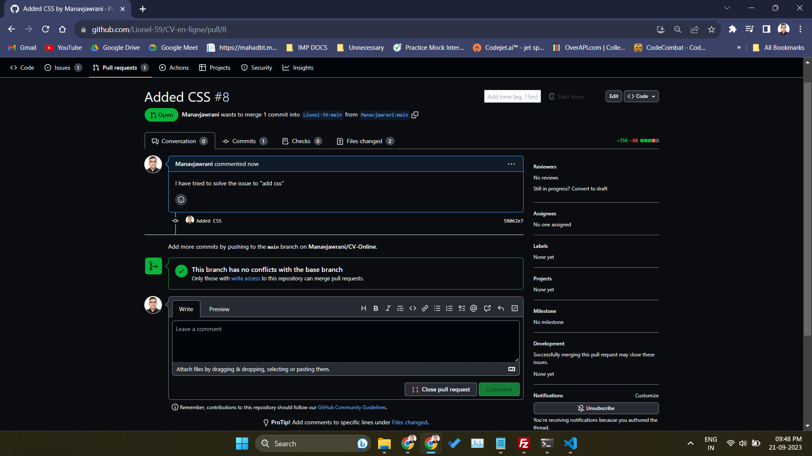

Pull Request Merged -

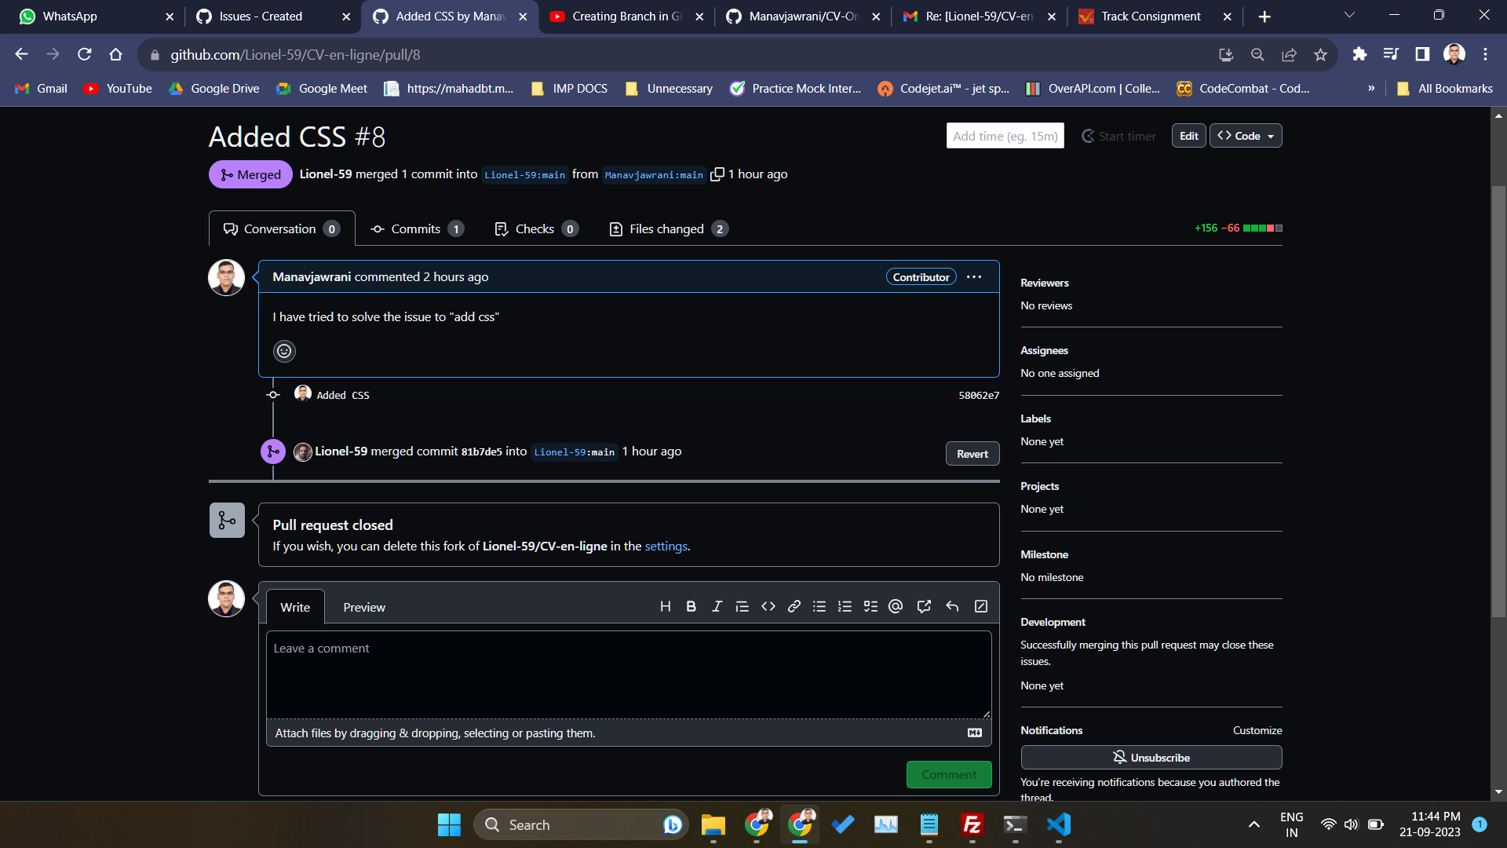

**Contribution 2 -**

Original Repository - <https://github.com/ramanabhinav7/OnlineCalculator>

Issue Link - <https://github.com/ramanabhinav7/OnlineCalculator/issues/2>

Forked Repository - <https://github.com/Manavjawrani/OnlineCalculator>

Solution to the issue - Adding the **script.js** file.

function appendToDisplay(value) {

document.getElementById('display').value += value;

}

function clearDisplay() {

document.getElementById('display').value = '';

}

function backspace() {

var currentValue = document.getElementById('display').value;

document.getElementById('display').value = currentValue.slice(0, -1);

}

function calculate() {

try {

var result = eval(document.getElementById('display').value);

document.getElementById('display').value = result;

} catch (error) {

document.getElementById('display').value = 'Error';

}

}

// Add event listener for Enter key press

document.getElementById('display').addEventListener('keyup', function(event) {

if (event.key === 'Enter') {

calculate();

}

});

Pull Request - <https://github.com/ramanabhinav7/OnlineCalculator/pull/3>

Screenshot of Pull Request -

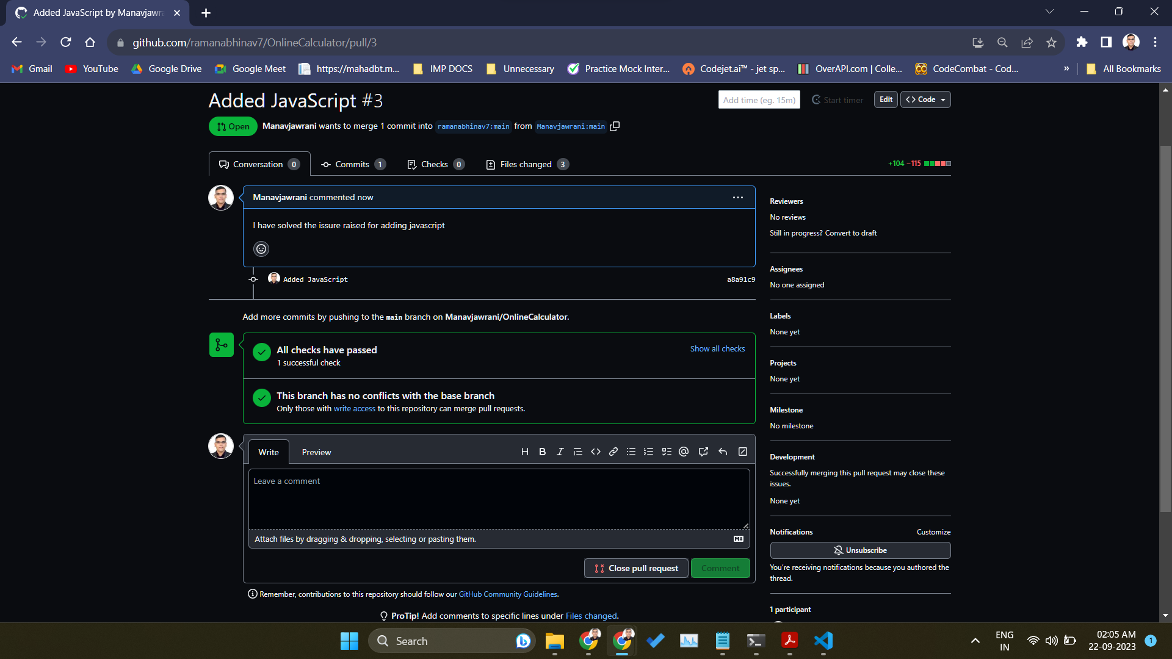

**Contribution 3 -**

Original Repository - <https://github.com/RhettRoseman/laughable-lamb>

Issue Link - <https://github.com/RhettRoseman/laughable-lamb/issues/3>

Forked Repository - <https://github.com/Manavjawrani/laughable-lamb>

Solution to the issue - Adding the **style.css** file.

/* Reset some default styles */

body, h1, h2, h3, p, ul {

margin: 0;

padding: 0;

}

body {

font-family: Arial, sans-serif;

background-color: #fff;

color: #000;

line-height: 1.6;

padding: 20px;

}

.container {

max-width: 800px;

margin: 0 auto;

background-color: #fff;

padding: 20px;

box-shadow: 0 0 10px rgba(0, 0, 0, 0.1);

}

h1 {

font-size: 36px;

color: #000;

margin-bottom: 20px;

text-align: center;

}

h2 {

font-size: 24px;

margin-top: 20px;

}

h3 {

font-size: 18px;

margin-top: 20px;

}

button {

background-color: #007bff;

color: #fff;

padding: 10px 20px;

border: none;

cursor: pointer;

border-radius: 4px;

margin-top: 10px;

}

button:hover {

background-color: #0056b3;

}

select {

padding: 10px;

margin: 10px 0;

}

form {

margin-top: 20px;

}

.makeup {

border: 1px solid #ccc;

padding: 10px;

margin: 10px 0;

}

#Results {

font-weight: bold;

margin-top: 20px;

}

#userList {

list-style-type: disc;

margin-left: 20px;

}

#resetBtn {

background-color: #dc3545;

}

#resetBtn:hover {

background-color: #c82333;

}

Pull Request - <https://github.com/RhettRoseman/laughable-lamb/pull/26>

Screenshot of Pull Request -

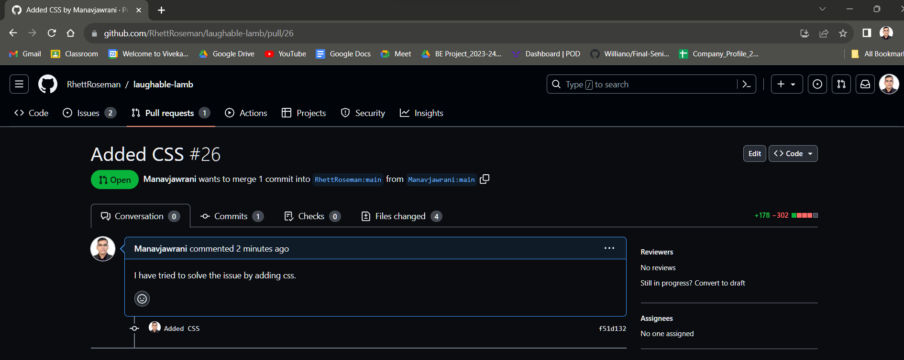

**Contribution 4**

**Original Repository** -<https://github.com/OliverM224/UOS-Website-Hacktoberfest>

**Issue Link -** <https://github.com/OliverM224/UOS-Website-Hacktoberfest/issues/2>

**Solution to the issue -** To add favicon

<!DOCTYPE html>

<html>

<head>

<link rel="icon" href="imgs/comps.png" type="image/x-icon">

<link rel="shortcut icon" href="favicon.ico" type="image/x-icon">

</head>

<body>

</body>

</html>

**Forked Repository** -<https://github.com/doulatlalwani/UOS-Website-Hacktoberfest>

**Screenshot of Pull Request -**

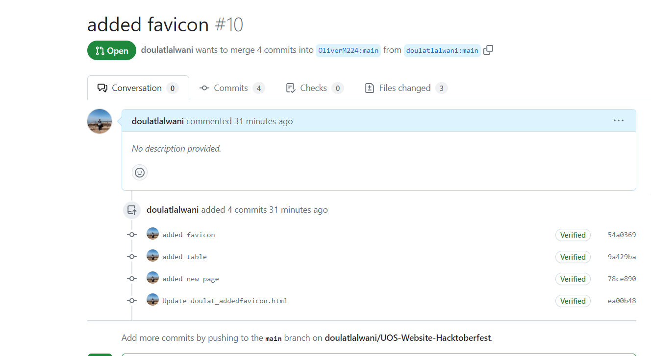

**Contribution 5**

**Original Repository** -<https://github.com/OliverM224/UOS-Website-Hacktoberfest>

**Issue Link** - <https://github.com/OliverM224/UOS-Website-Hacktoberfest/issues/3>

**Solution to the issue -** To add table

<!DOCTYPE html>

<html>

<head>

<title>Upcoming Events include</title>

</head>

<body>

<h1>Upcoming Events include</h1>

<table border="1">

<tr>

<th>Date</th>

<th>Event</th>

<th>location</th>

</tr>

<tr>

<td>27 Sep 23</td>

<td>Welcome & Introductions</td>

<td>A208</td>

</tr>

<tr>

<td>4 Oct 23</td>

<td>Hacktoberfes</td>

<td>A208</td>

</tr>

<tr>

<td>11 Oct 23</td>

<td>Geek Retreat Social Event (3pm-6pm)

Meet at the Question Mark statue if you want to walk in a group.</td>

<td>Geek Retreat</td>

</tr>

<tr>

<td>18 Oct 23</td>

<td>Careers Talk & Job Interview VR Software Demo</td>

<td>A208</td>

</tr>

<tr>

<td>25 Oct 23</td>

<td>No Event-Reading Week</td>

<td>N/A</td>

</tr>

<tr>

<td>01 Nov 23</td>

<td>Suffolk Tech Industry Day (Mandatory attendance for all students) 09:00-16:30</td>

</tr>

<tr>

<td>08 Nov 23</td>

<td>Build Your Own Website & Online Shop using WordPress and WooCommerce</td>

<td>A208</td>

</tr>

<tr>

<td>15 Nov 23</td>

<td>Student Support Session</td>

<td>A208</td>

</tr>

<tr>

<td>22 Nov 23</td>

<td>3D printing</td>

<td>A208</td>

</tr>

<tr>

<td>1 Dec 23</td>

<td>Christmas Social Event-Details TBC/Games Room/Film Showing</td>

<td> </td>

</tr>

<tr>

<td>6 Dec 23</td>

<td>No Event-Student Module Preparation Week</td>

<td>N/A</td>

</tr>

<tr>

<td>13 Dec 23</td>

<td>No Event-Student Module Preparation Week</td>

<td>N/A</td>

</tr>

<tr>

<td>10 Jan 24</td>

<td> </td>

<td>A208</td>

</tr>

<tr>

<td>17 Jan 24</td>

<td>Pail Loper Cyber Security Talk (New Date) </td>

<td>A208</td>

</tr>

</table>

</body>

</html>

**Forked Repository -**<https://github.com/doulatlalwani/UOS-Website-Hacktoberfest>

**Screenshot of pull request:-**

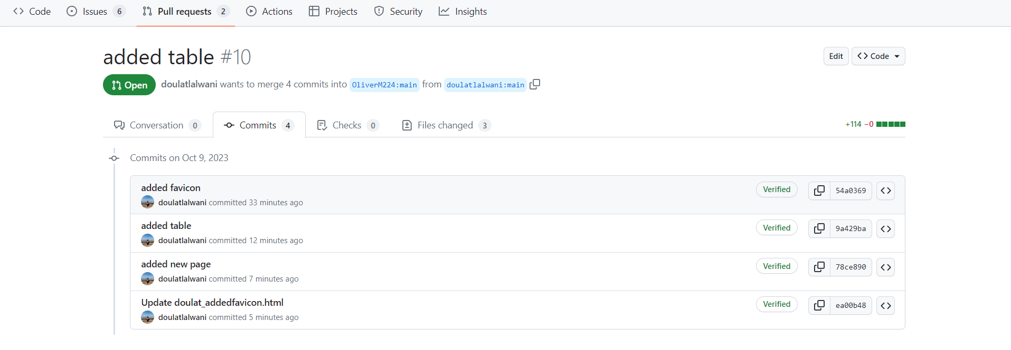

**Contribution 6**

**Original Repository** -<https://github.com/OliverM224/UOS-Website-Hacktoberfest>

**Issue Link -** <https://github.com/OliverM224/UOS-Website-Hacktoberfest/issues/4>

**Solution to the issue -** To add new page

<!DOCTYPE html>

<html>

<head>

<title>My Website</title>

</head>

<body>

<nav>

<ul>

<li><a href="index.html">Home</a></li>

<li><a href="doulat_addednewpage.html">New Page</a></li>

<!-- Add more navigation links as needed -->

</ul>

</nav>

<h1>Welcome to My Website</h1>

<p>This is the content of the home page.</p>

</body>

</html>

**Forked Repository** -<https://github.com/doulatlalwani/UOS-Website-Hacktoberfest>

Pull Request -

Screenshot of pull request:-

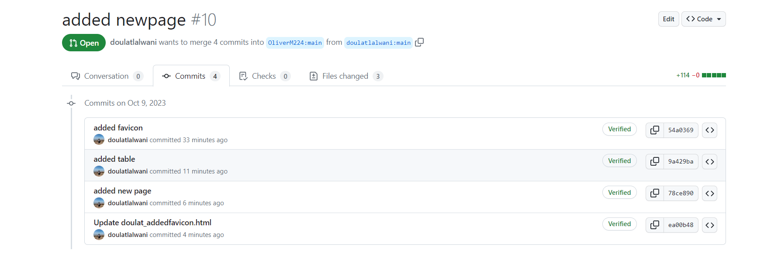

**Contribution 7 -**

Original Repository -<https://github.com/alazul2014/Sign-up>

Issue Link - <https://github.com/alazul2014/Sign-up/issues/9>  
Forked Repository - <https://github.com/Samartha29/Sign-up>

Solution to the issue - Adjust new selector paddings to get the selector visible on any screen size and window size

body {

font-family: Arial, Helvetica, 'sans-serif';

background-image: url('https://i.pinimg.com/originals/89/b4/19/89b4198d2d3fc5007510626163b7759f.jpg');

background-repeat: no-repeat;

background-position: center center;

background-size: cover;

background-attachment: fixed;

margin-left: 0; /* Instead of a fixed margin, let's start from the left edge */

margin-right: 0; /* Reset right margin */

}

.menu ul {

display: flex;

padding: 0;

margin: 0;

list-style: none;

}

.menu a {

border-radius: 0.2em;

display: block;

padding: 1em; /* Adjusted padding for better responsiveness */

background-color: #7941c2c5;

text-decoration: none;

color: #191C26;

}

.menu a:hover {

background-color: #8f63c9c5;

}

.menu ul li ul {

display: none;

}

.menu ul li a:hover + ul,

.menu ul li ul:hover {

display: block;

}  
  
Pull Request - [https://github.com/alazul2014/Sign-up/pull/9](https://github.com/alazul2014/Sign-up/issues/9)

Screenshot of Pull Request -  
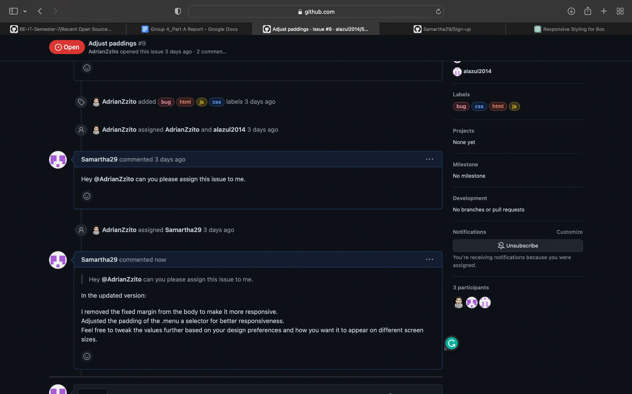

**Contribution 8 -**

Original Repository - <https://github.com/linzinha/test_env_template>

Issue Link - <https://github.com/linzinha/test_env_template/issues/3>

Solution to the issue - use a simple grid layout and includes placeholders for product name, picture, quantity selection, price, and an "Add to Cart" button.  
<!DOCTYPE html>

<html lang="en">

<head>

<meta charset="UTF-8">

<meta name="viewport" content="width=device-width, initial-scale=1.0">

<title>E-commerce Products</title>

<style>

body {

font-family: Arial, sans-serif;

margin: 20px;

}

.product-grid {

display: grid;

grid-template-columns: repeat(auto-fill, minmax(250px, 1fr));

gap: 20px;

}

.product-card {

border: 1px solid #ddd;

padding: 15px;

text-align: center;

}

.product-image {

max-width: 100%;

height: auto;

margin-bottom: 10px;

}

.add-to-cart-button {

background-color: #3498db;

color: #fff;

padding: 10px;

border: none;

cursor: pointer;

}

</style>

</head>

<body>

<h1>Product List</h1>

<div class="product-grid">

<!-- Product 1 -->

<div class="product-card">

<img src="product1.jpg" alt="Product 1" class="product-image">

<h2>Product Name 1</h2>

<p>Price: $19.99</p>

<label for="quantity1">Quantity:</label>

<input type="number" id="quantity1" value="1" min="1">

<button class="add-to-cart-button">Add to Cart</button>

</div>

<!-- Product 2 -->

<div class="product-card">

<img src="product2.jpg" alt="Product 2" class="product-image">

<h2>Product Name 2</h2>

<p>Price: $29.99</p>

<label for="quantity2">Quantity:</label>

<input type="number" id="quantity2" value="1" min="1">

<button class="add-to-cart-button">Add to Cart</button>

</div>

<!-- Add more product cards as needed -->

</div>

</body>

</html>

Forked Repository - <https://github.com/Samartha29/test_env_template>

Pull Request - <https://github.com/linzinha/test_env_template/pull/10>

Screenshot of Pull Request -  
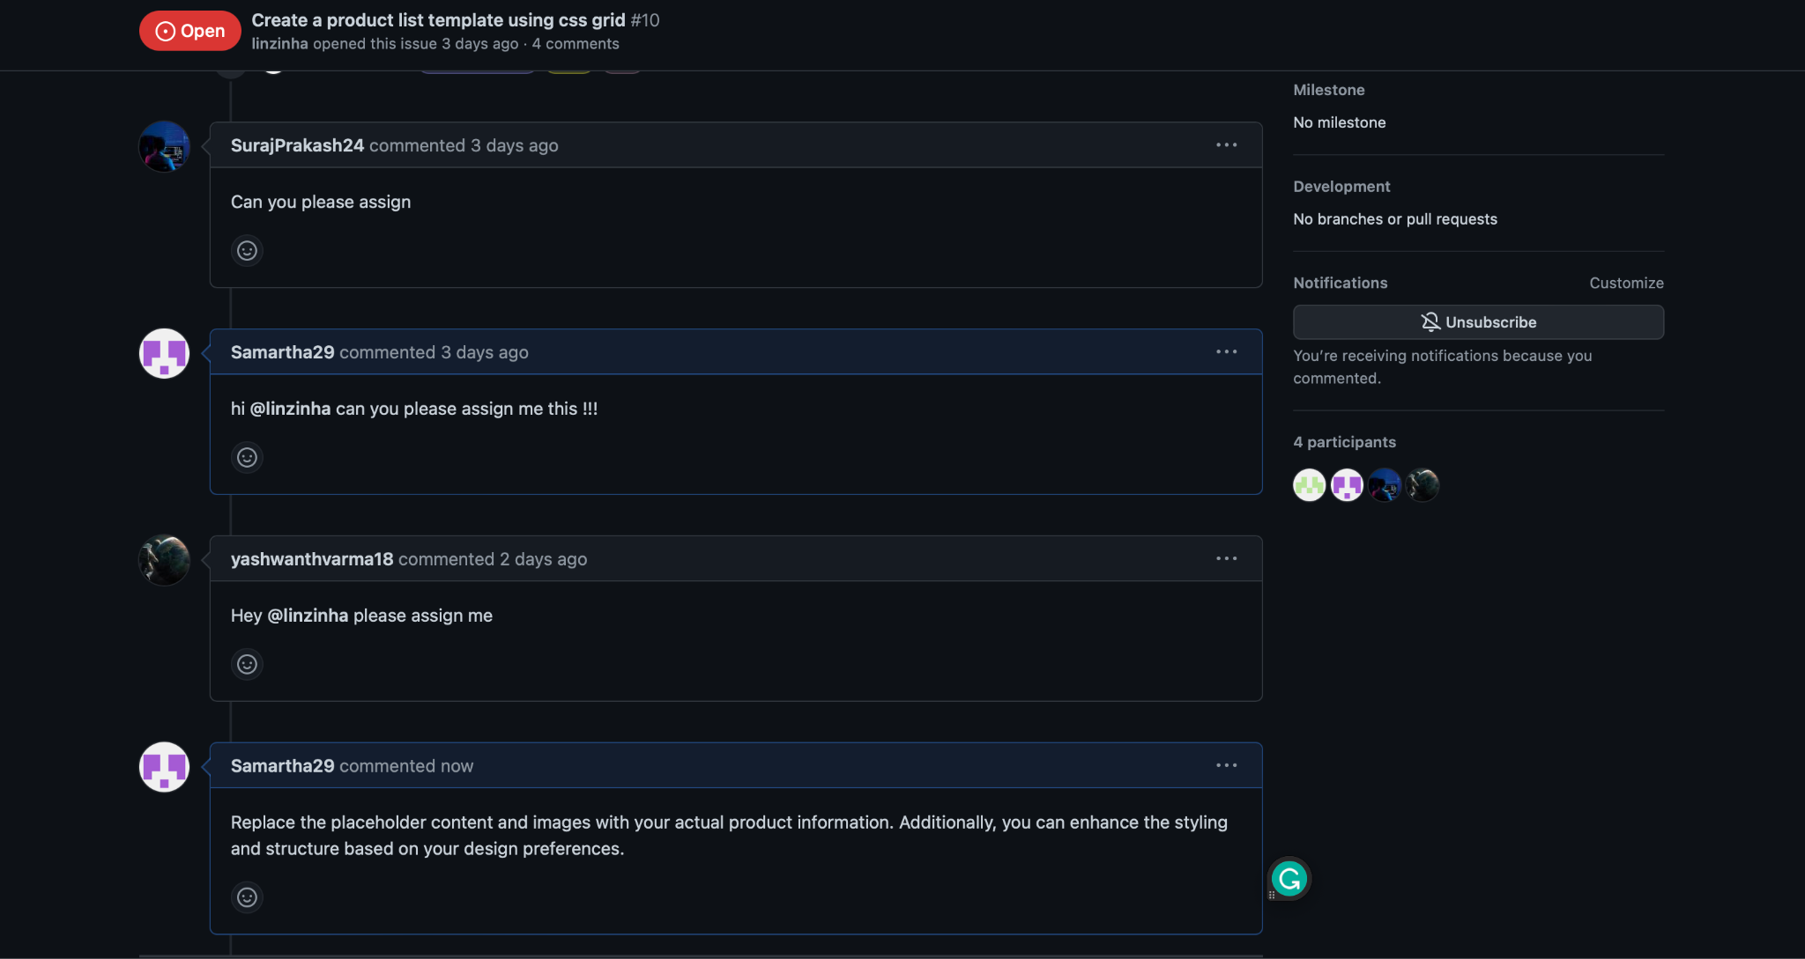

Contribution 9

Original Repository -<https://github.com/linzinha/test_env_template>

Issue Link - <https://github.com/linzinha/test_env_template/issues/6>

Solution to the issue -

<!DOCTYPE html>

<html lang="en">

<head>

<meta charset="UTF-8">

<meta name="viewport" content="width=device-width, initial-scale=1.0">

<title>Login Page</title>

<style>

body {

font-family: Arial, Helvetica, sans-serif;

background-color: #f2f2f2;

text-align: center;

}

.login-container {

max-width: 400px;

margin: 0 auto;

padding: 20px;

background-color: #ffffff;

border-radius: 5px;

box-shadow: 0px 0px 10px rgba(0, 0, 0, 0.2);

}

.login-container h2 {

margin-bottom: 20px;

}

.input-group {

margin-bottom: 20px;

}

.input-group label {

display: block;

margin-bottom: 5px;

font-weight: bold;

}

.input-group input {

width: 100%;

padding: 10px;

border: 1px solid #ccc;

border-radius: 3px;

}

.login-button {

background-color: #007bff;

color: #fff;

padding: 10px 20px;

border: none;

border-radius: 3px;

cursor: pointer;

}

.login-button:hover {

background-color: #0056b3;

}

</style>

</head>

<body>

<div class="login-container">

<h2>Login</h2>

<form action="your-server-endpoint.php" method="POST">

<div class="input-group">

<label for="username">Username:</label>

<input type="text" id="username" name="username" required>

</div>

<div class="input-group">

<label for="password">Password:</label>

<input type="password" id="password" name="password" required>

</div>

<button type="submit" class="login-button">Login</button>

</form>

</div>

</body>

</html>

Screenshot of Pull Request -

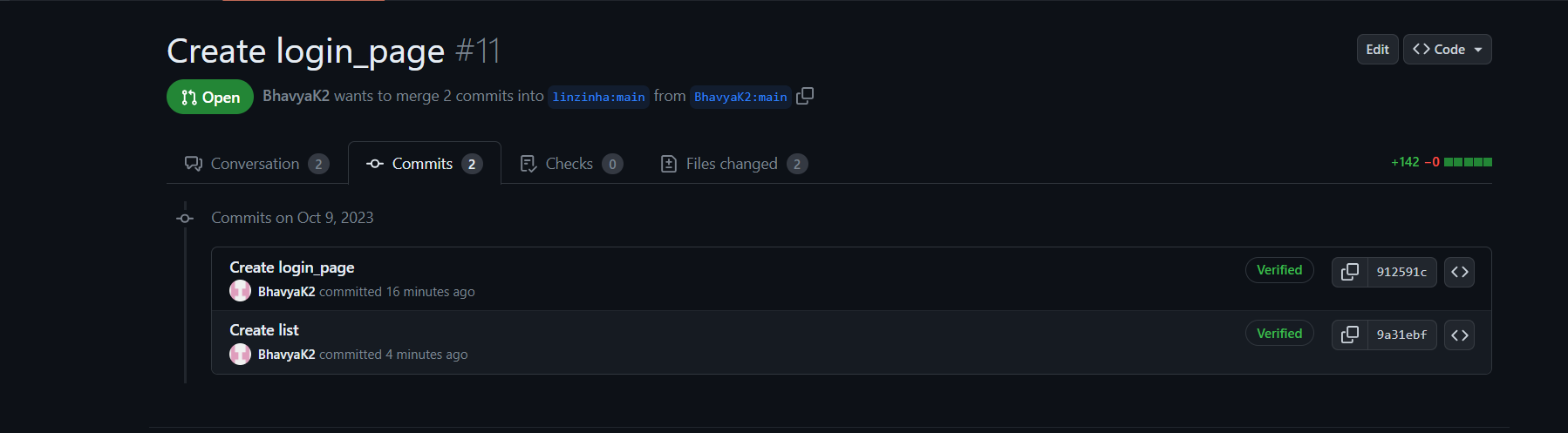

Contribution 10

Original Repository - <https://github.com/linzinha/test_env_template>

Issue Link - <https://github.com/linzinha/test_env_template/issues/10>

Solution to the issue -

<!DOCTYPE html>

<html lang="en">

<head>

<meta charset="UTF-8">

<meta name="viewport" content="width=device-width, initial-scale=1.0">

<title>Product List</title>

<style>

body {

font-family: Arial, sans-serif;

background-color: #f2f2f2;

margin: 0;

padding: 0;

}

.product-list {

display: grid;

grid-template-columns: repeat(auto-fill, minmax(200px, 1fr));

grid-gap: 20px;

max-width: 1200px;

margin: 20px auto;

padding: 20px;

background-color: #ffffff;

box-shadow: 0px 0px 10px rgba(0, 0, 0, 0.2);

}

.product-item {

border: 1px solid #ccc;

padding: 10px;

text-align: center;

background-color: #fff;

}

.product-item img {

max-width: 100%;

height: auto;

}

.product-title {

font-weight: bold;

margin: 10px 0;

}

.product-price {

color: #007bff;

}

</style>

</head>

<body>

<div class="product-list">

<!-- Product 1 -->

<div class="product-item">

<img src="product1.jpg" alt="Product 1">

<div class="product-title">Product 1</div>

<div class="product-price">$19.99</div>

</div>

<!-- Product 2 -->

<div class="product-item">

<img src="product2.jpg" alt="Product 2">

<div class="product-title">Product 2</div>

<div class="product-price">$24.99</div>

</div>

<!-- Add more products here -->

</div>

</body>

</html>

Forked Repository - <https://github.com/BhavyaK2/login_page>

Screenshot of Pull Request -

